Develop a python Script

Create a code snippet using python compiler
1. Extract weather data from OpenWeatherMap using APIs
2. Send the extracted data to the cloud
3. Receive data from the cloud and view it in the python compiler

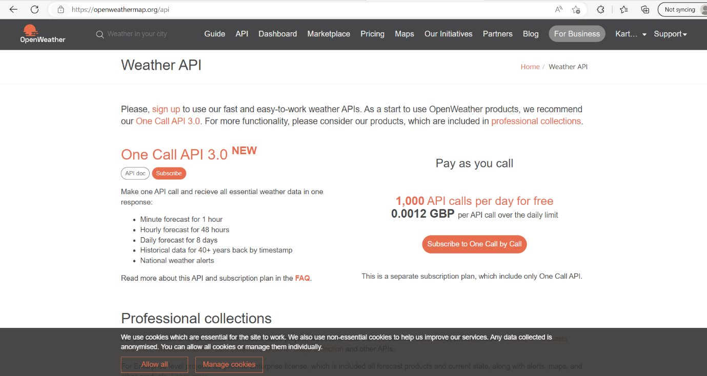
1. Extract weather data from OpenWeatherMap using APIs:
Date | 22 November 2022
Team ID | PNT2022TMID44492
Project Name | Signs with smart connectivity for Better road safety
Maximum Marks | 4 Marks
2. Send the extracted data to the cloud:

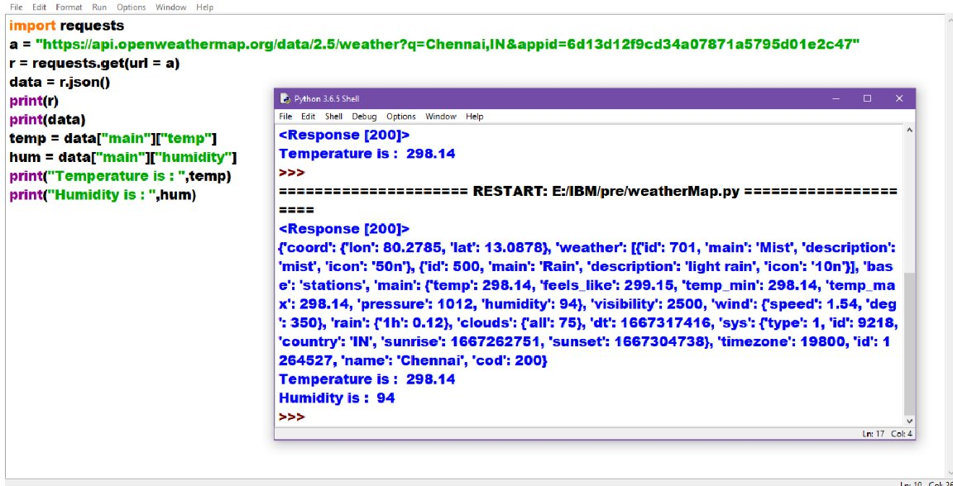
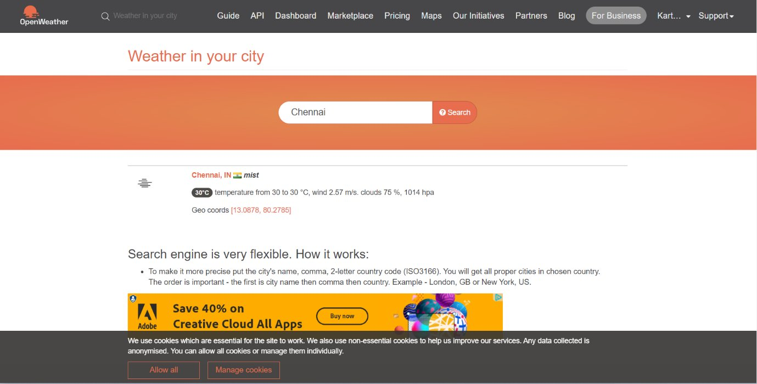
3. Receive data from the cloud and view it in the python compiler:

